COLLEGE ADMISSION SYSTEM
ABSTRACT
Today all the work at the time of admission of the students is done manually by ink and paper, which is very slow and consuming much efforts and time. It is required to Design of a Computerized Automated Student Admission System, to speed up and make it easy to use system. Student admissions are a vital part of any university’s running because students are what keep a University alive. The student admission is one of the most important activities within a university as one cannot survive without students. A poor admissions system can mean fewer students being admitted into a university because of mistakes or an overly slow response time. The process begins with a potential student completing an application form through the Universities and Colleges Admissions Service, the first step for students is to apply directly to the university through a custom online form. This project’s aim is to automate the system, prechecking the inclusion of all required material and automatically ranking each student’s application based on a number of criteria. These criteria include the ranking of their university, their grade at said university and their language grade Certificate. The data used by the system is stored in a database that will be the center of all information held about students and the base for the remainder of the process after the initial application has been made. This enables things to be simplified and considerably quickened, making the jobs of the people involved easier. It supports the current process but centralizes it and makes it possible for decisions to be made earlier and easier way.

SYSTEM SPECIFICATION
HARDWARE SPECFICATION:
- Processor : P 4 700 GHz.
- RAM : 4 GB RAM
- Hard Disk Drive : 180 GB

SOFTWARE SPECIFICATION:

  - Operating System : Windows 7/8/10
  - Front End : JAVA
  - Back End : SQL

EXISTING SYSTEM:
The college admission system has to handle records for many numbers of students and maintenance was difficult. Though it has used an information system, it was totally manual. Hence there is a need to upgrade the system with a computer-based information system.
DRAWBACKS:
- Waste of time
- Allocate student as class wise
- Very hard to manage admission system manually

PROPOSED SYSTEM:
In this system overcome these all kind of issues. Systematically students are assigned the class. With the help of the system, it could not be conflict. So, it takes very less time to allocate the student process.
FEATURES:
By developing the system, we can attain the following features:
- It’s automated computerized web-based software system
- It uses technologies like html
- It’s easy to operate
- Attractive user interface

MODULES:
- Admin Login
Here admin is an teachers/admission employee, they are using this application to mapping student to the registered department. Each and every request should approve by an admin
- Student Registration
Student registration module is containing lot of fields for collect the student details. Which is the first module for this application. Based on this detail’s student will be allocated to the admission
- Student Approval
Once the student registers the application, then the notification has sent to the admin, then admin decide to execute approve or reject. This is an main action for the application once the student has rejected they will be not allocated
- Seat Allocate
After admin approval for student registration form, then seat will be allocating to the requested department. Accepted student count can’t be more than maximum no of student count.
- Class wise student details
Finally, this module generates and display class wise student details, we can easily find out the student details as a class wise. This will very helpful to find the all-student details in a single window. Both admin and teachers can able to view the student list.

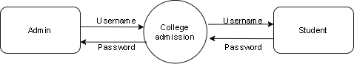

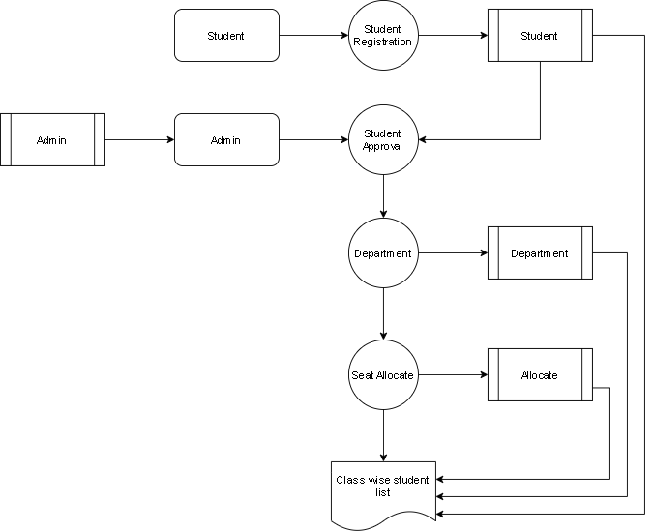

TABLE NAME: ADMIN

FIELD | DATA TYPE | SIZE | CONSTRAINT
Admin id | Int | 10 | Primary key
Username | Varchar | 30 | Not null
password | Varchar | 30 | Not null

TABLE NAME: DEPARTMENT
FIELD | DATA TYPE | SIZE | CONSTRAINT
Department id | Int | 10 | Primary key
Department name | Varchar | 30 | Not null
Total seat | Int | 5 | Not null

TABLE NAME: STUDENT

FIELD | DATA TYPE | SIZE | CONSTRAINT
Student id | Int | 10 | Primary key
First name | Varchar | 15 | Not null
Last name | Varchar | 15 | Not null
Mobile | int | 10 | Not null
Email | Varchar | 30 | Not null
Age | Int | 5 | Not null
Gender | Varchar | 7 | Not null
Address | Varchar | 30 | Not null
Department | Varchar | 10 | Not null
Class name | Varchar | 10 | Not null
10th mark | Int | 5 | Not null
12th mark | Int | 5 | Not null
School name | Varchar | 30 | Not null
Father name | Varchar | 15 | Not null
Mother name | Varchar | 15 | Not null

TABLE NAME: ALLOCATE

FIELD | DATA TYPE | SIZE | CONSTRAINT
Allocate id | Int | 10 | Primary key
Dept allocate id | Int | 10 | Foreign key
Class id | Int | 10 | Foreign key
Student id | Int | 10 | Foreign key
Confirmation | Varchar | 15 | Not null

